Freight Pricing Analysis Model
- Models + Validation approach
- The model used was Gradient Boost regressor with an R2 of 0.88 meaning the model explains 88% of the actual values.
- Therefore validation predicted rate gives an accuracy of 88%
- Prophet time series model was used to predict market index and quote signal for the December values.
- The GBR model was then run through the predicted and existing data

- Data split approach
- A train test split of 70/30 was used to avoid overfitting
- For the GBR model a random split allows better performance training to allow the tree classification to find deeper and better paths
- For the prophet model, chronological data split has to be done to ensure the trend is maintained
- candidate_december.png chart
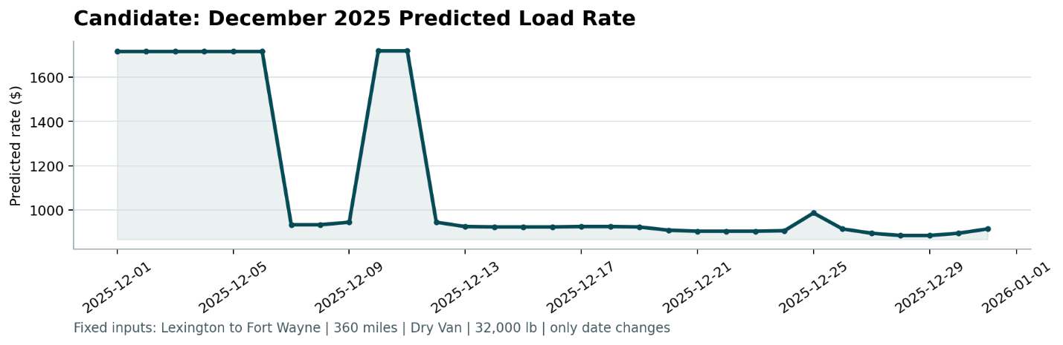
This chart follows the trend seen on market signal and quote signal.
Ideally if we went by distance only, the graph would be a constant value
However due to the trend on trained data where there is a continuous dip from October this output picks that trend. Picking the rise and fall on weekly pricing shifts on market signal as well as the dips on quote signal.

More data and context for a numerous years and seasonal trends would give a better output.

